Push the image to the IBM Cloud Registry

1. From your account dashboard, go to **IBM Cloud Kubernetes Service**.
2. From the left navigation menu, select **Private Repositories**.

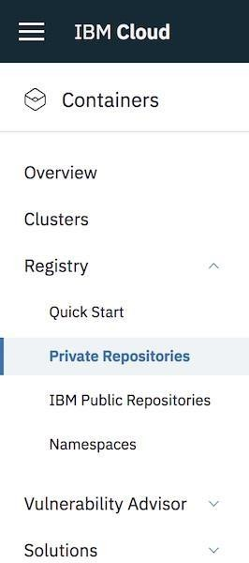

1. Install the Container Registry plug-in.
2. ibmcloud plugin install container-registry -r "IBM Cloud"
3. Log in to your IBM Cloud account.

6. ibmcloud login -a <cloud_foundary_end_point_for_the_region>

1. Name and create your namespace. Use this namespace for the rest of the Quick Start.
2. ibmcloud cr namespace-add <namespace>
3. Log your local Docker daemon into the IBM Cloud Container Registry.
4. ibmcloud cr login
5. Choose a repository and tag by which you can identify the image.
6. docker tag <image_name> <region_url>/<namespace>/<image_name>:<tag>
7. Push the image.
8. docker push <region_url>/<namespace>/<image_name>:<tag> 
9. Verify that your image is in your private registry.

16. ibmcloud cr image-list

